**LITERATURE SURVEY**

Abstract:

In our daily life, the textile and fashion industries have witnessed always an enormous amount of growth in fast fashion. On e-commerce platforms, where numerous choices are available, an efficient recommendation system is required to sort, order, and efficiently convey relevant product content or information to users. Image-based fashion recommendation systems (FRSs) have attracted a huge amount of attention from fast fashion retailers as they provide a personalized shopping experience to consumers.

The rapid progress of computer vision, machine learning, and artificial intelligence combined with the current growing urge for online shopping systems opened an excellent opportunity for the fashion industry. As a result, many studies worldwide are dedicated to modern fashion-related applications such as virtual try-on and fashion synthesis. However, the accelerated evolution speed of the field makes it hard to track these many research branches in a structured framework.

**Problem Statement**:

In this project, we make use of cloud app development and to come up with a new innovation solution through which you can directly do your online shopping based on your choice without any search. The user will login into the website and go through the products available on the website. Instead of, navigate to several screen for booking products online, the user can directly talk to chatbot regarding the products. Get the recommendation based on information provided by the user.

Only in E-commerce websites, customers need to search for their desired products and navigate across screens to view the product, and also accessed to add them to the cart, also addition to order the products. This smart fashion recommender application mainly uses the chat bot to interact with the users, gather information about their preferences, and recommend suitable products to the users.

This application has two defined roles assigned to the users. The roles are customer and admin. Admin should be able to track the number of different products and admin should be assigned the responsibility to create products with appropriate categories. The user should be able to mention their preferences using interacting with chat bots. The user must receive a notification on order confirmation/failure. The chat bot must gather feedback from the user at the end of order confirmation. The main objective of this application is to provide better interactivity with the user and to reduce navigating pages to find appropriate products.

**Problem Description:**

We have come up with a new innovative solution through which you can directly do your online shopping based on your choice without any search. It can be done by using the chatbot. In this project you will be working on two modules:

1. Admin

2. User

**Methodology used in the solution:**

To avoid searching of multiple products in the search bar, user can interact with the chatbots, the chatbots can easily identify what product the user wants to buy, so it will be easy for the admin to recommend the user satisfied product by the conversation with the chat bot. The chatbot send the messages periodically in order to recommend and offers a customer satisfied product. For the security purpose, this application uses a token to authenticate and authorize users securely. The token has encoded user id and the role. Based on the encoded information, access to the resources is restricted to the specific users.

**System Architecture**

DATABASE

USER

SERVER FLASK API

ADMIN

MAIL GENERATION

**Chat Bot Working**

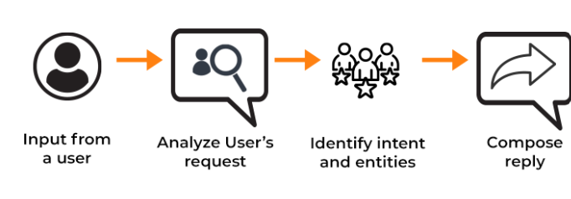

**Authentication**

1.1 Login 1.2 Check User Profile

{User, password} {validate}

Database

Server

Client

Access token, Validate User

refresh token

**OAuth Generation**

{refresh token}

Server

Client

{Access Token}

{OAuth-refresh token}

{Profile-access token}

**Features**

* Using chatbot we can manage users' choices and orders.
* The chat bot can give recommendations to users based on their interests.
* It can promote the best deals and offers on that day.
* It will store the customer's details and orders in the database.
* The chat bot will send a notification to customers if the order is confirmed.
* Chat bots can also help in collecting customer feedback.

**METHODOLOGY PROPOSED**

In the traditional method, users need to search for their required product using a search bar or go through the whole effects of their search. It will take a lot of users' time and it will create a lot of flawed user experiments. This approach will create bad marketing for the product. Later when the user comes again to purchase the product it will create a bad impression on the user. Even though the product is good the user will not buy the product. This type of search will create miss matched products when the product has a different name. we search for oranges on amazon.

Sometimes it will show orange colour or sometimes it will show orange fruit. In recent times, fashion systems have been integrated with artificial intelligence and deep learning. These approaches provide a rich recommendation, but in most cases, it is prone to product mismatch. Even Though the recommender system recommends products based on the user’s preference, this system lacks a chat bot that improves user experience by interacting with users. In most fashion systems, the user needs to navigate across multiple products to find the appropriate product. The users are made to filter products based on the long list of categories present in the system. If this system is integrated with an intelligent bot, it would be able to list out only required categories.

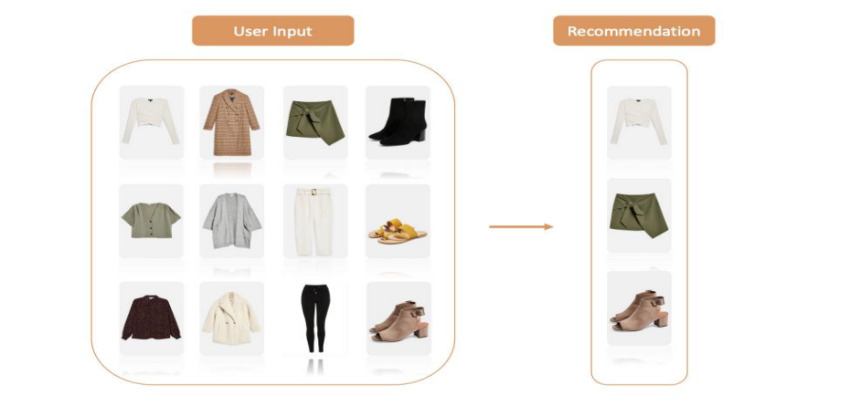

**Hardware Requirements**

* 8GB RAM
* Intel Core i3
* Laptop/Desktop
* Windows/MAC/Linux OS.

**Software Requirements**

* Python
* Flask
* Docker
* Kubernetes
* IBM DB

**Conclusion**

The smart fashion recommender system uses a chat bot as a primary mechanism to interact with users, collect user interest and recommend products periodically. A chat bot is designed to improve user experience by interacting with users. Users need not navigate between multiple pages to find an appropriate product. The system is designed to minimize the efforts taken by customers to search for the required product. The future enhancements of the chat bot include adding products to the cart, displaying cart items, order history, and payment through the chat bot.

**References:**

* Samit Chakraborty, Md. Saiful Hoque, Naimur Rahman Jeem-Fashion Recommendation Systems, Models and Methods: A Review
* Qingqing Tu, Le Dong-An Intelligent Personalized Fashion Recommendation System
* M Sridevi, N ManikyaArun, M Shashikala, and E Sudarshan-Personalized fashion recommender system with image-based neural network